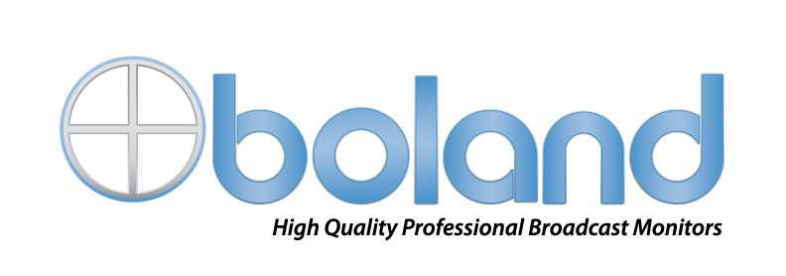

**LVB21**

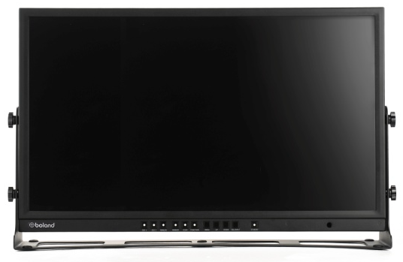

**21” HD & SD SDI Digital, Analog, HD HDMI/DVI (+HDCP)**

•High & Standard Definition Video LCD Monitors 1080/720/576/480(@60/59.94/50)

•3G includes 2x3G HD/SD SDI-Digital input/ HD HDMI/DVI (+HDCP)

•HDMI/DVI inputs accepts up to 1080p HD

•Modes: EGA to UXGA, NTSC/PAL/SECAM/NTSC4.43/PAL-M

•Analog Inputs are Composite, Y/C, Component, RGB(SOG), DVI – I(Analog PC)

•Aspect Ratio: 16:9, 4:3, 14:9, 13:9, 1.85:1, 2.35:1:

•Marker Display. •UMD Support.

•Color Temperature – User, VAR, 11000K, 9300K, 6500K, 5400K, 3200K

|  |  |
| --- | --- |
| ***SPECIFICATIONS*** | |
| **Active Area (Diagonal):** | 21.5” |
| **MODES** | |
| **High & Standard Definition Video Modes:** | 1920x1080p(50/60/30psf/25psf/24psf/30/25/24),1920x1080i(50/60), 1280x720p(50/59.94/60), 480i(59.94),576i(50)  Digital, VESA VGA, DVI/HDMI  *24psf/23.98psf signal format is not supported in “UNDERSCAN ” Mode. |
| **PC Video Modes:** | EGA, VGA, SVGA, XGA, WXGA, SXGA, WSXGA, UXGA |
| **Standard Definition Video Modes:** | NTSC/PAL/SECAM/NTSC4.43/PAL-M |
| **Scanning Modes:** | Under/Over/Zero/Pixel to Pixel Scanning |
| **INPUTS** | |
| **Digital Video Inputs:** | 3G HD SDI (@50/59.94/60), HD HDMI/DVI (+HDCP) |
| **Digital Video Inputs:** | Digital Visual Interface, VESA & SMPTE Rates. |
| **Analog Video Inputs:** | Composite, Y/C, Component, RGB(SOG), DVI – I(Analog PC) |
| **PICTURE** | |
| **Aspect Ratios:** | Full Screen, 16:9, 4:3, 14:9, 13:9, 1.85:1, 2.35:1 |
| **Picture-in-Picture :** | Analog (Composite1, 2, 3, Y.Pb.Pr, GBR, PC),SDI 1 inputs + SDI 2, Digital (DVI, HDMI) input PIP |
| **Picture-by-Picture:** | Side by Side split screen display |
| **Pixel (RGB Trio) Arrangement:** | 1920 H x 1080 V Pixels RGB strip arrangement(2,073,600 Pixes, 16:9) |
| **Pixel (RGB Trio) Pitch, Depth:** | 0.08265 x 0.24795mm |
| **Brightness, typical, 0°:** | 250 cd/m2 |
| **Contrast Ratio, 0°** | 1000:1 |
| **Color Processor:** | 10 bit color Processor |
| **Viewing Angle** | Horizontal: 178(Typ),Vertical 178(Typ), 1000:1 |
| **Response Time:** | 5 ms |
| **CONTROLS** | |
| **User Controls:** | STANDBY, SDI 1, SID 2, ANALOG, MARKER, FUNCTION, MENU, UP, DOWN, SEL/INPUT |
| **Remote Controls:** | IR, TCP/IP, RS-422, RS-232 |
| **LIGHT** | |
| **Light Source (standard):** | LED backlight system |
| **LED Life:** | 12,000 Hrs |
| **CONNECTORS** | |
| **Video Connectors:** | BNC x 2 SDI 2 Channel Input, BNC x 3 Composite, YC(S-Video), Component(YPbPr/RGB) Input |
| **HDMI/DVI Connectors:** | DVI-I x 1 DVI & Analog RGB Input, HDMI x 1 HDMI Input |
| **POWER** | |
| **DC Power:** | 12 VDC ±10%, 40 watts |
| **DC Connector:** | XLR-4M (pin 1=Gnd, pin 4=+volts) |
| **AC Power (detached power supply included):** | 90-264 VAC, 50/60 Hz |
| **AC Power Connector:** | IEC 320-C14 3 pin Male |
| **DISPLAY** | |
| **Cabinet Dimensions:** | 20.197” x 12.551” x 2.165” |
| **Weight:** | 20.7 lbs |
| **Mounting / Rack Mounting:** | VESA (100 x 100) |
| **Operating (full spec):** | 0 ~ +50°C, no condensation, 0 ~ 10,000 feet (3,048m) |
| **Storage:** | -20 ~ +60°C, no condensation, 0 ~ 40,000 feet (12,192m) |
| **Available Options:** | - |

16 Rancho Circle • Lake Forest, CA 92630 USA • (800) 918-9090 • (949) 465-9911 • Fax: (949) 465-9944 • [**www.bolandcom.com**](http://www.bolandcom.com)

|  |
| --- |
| Controls, Indicators and Connections |



|  |
| --- |
|  |